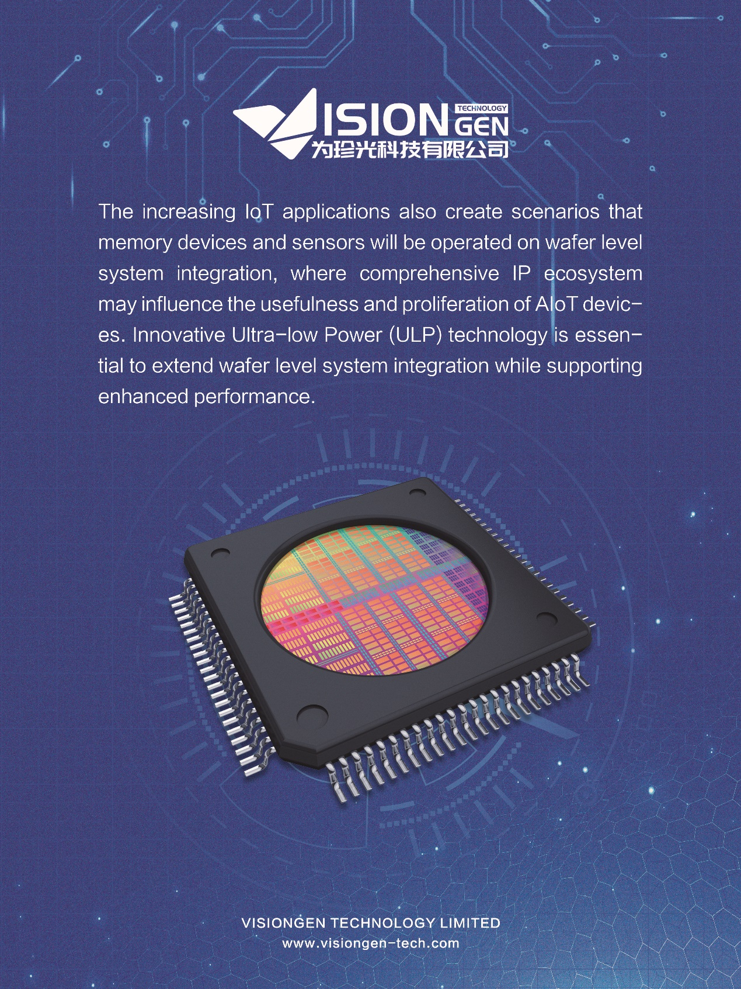

The mobile devices have enjoyed epic growth over the past decade in both software and hardware. The deployment of 5G will greatly enhance the wireless data communication bandwidth, latency and the density of connected devices. Wafer level system integration will also greatly enhance the features and performance of devices as well as enabling new services and businesses. 5G edge computing will emerge to support localized, low latency or even real time applications. Furthermore, 5G will also enable service providers to collect huge data for deep learning AI based new services. 5G and AI will together bring unprecedented services and conveniences into our life. Therefore, the underlying memory technologies need continuous improvement to support the power, performance, density improvement and feature augmentation needs.

Fast growing IoT devices lead to exponential growth of data that will be processed through intelligent AI model to make devices smarter and enrich user experience. Combined with 5G infrastructure that enables massive M2M networking, low latency communication and fast connection, wide range of (AI+IoT) applications can be realized.

The increasing IoT applications also create scenarios that memory devices and sensors will be operated on wafer level system integration, where comprehensive IP ecosystem may influence the usefulness and proliferation of AIoT devices. Innovative Ultra-low Power (ULP) technology is essential to extend wafer level system integration while supporting enhanced performance.