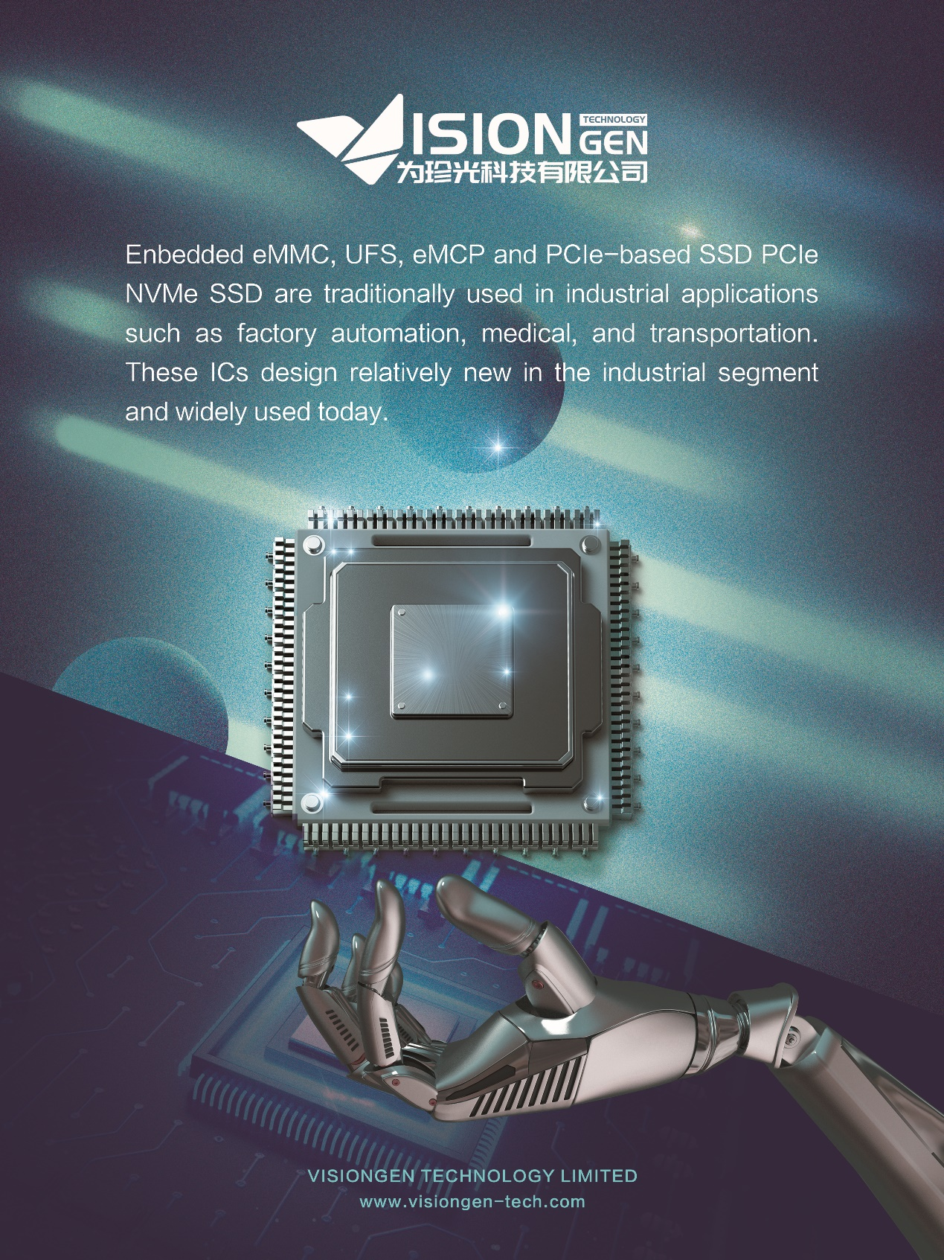

Enbedded eMMC, UFS, eMCP and PCIe-based SSD PCIe NVMe SSD are traditionally used in industrial applications such as factory automation, medical, and transportation. These ICs design relatively new in the industrial segment and widely used today. In addition to having a removable M.2 form factor, the BGA form factor offers a highly ruggedized solution for industrial applications, providing up to 1TB of storage space. Systems requiring greater than 1TB can utilize multiples of these devices to take advantage of the 16mm x 20mm package size. Automotive MCP not only need memory configurations with the right mix of density, power, performance, temperature, reliability and cost, but they also require solutions in a very small footprint. MCPs are optimal solutions for V2X communications