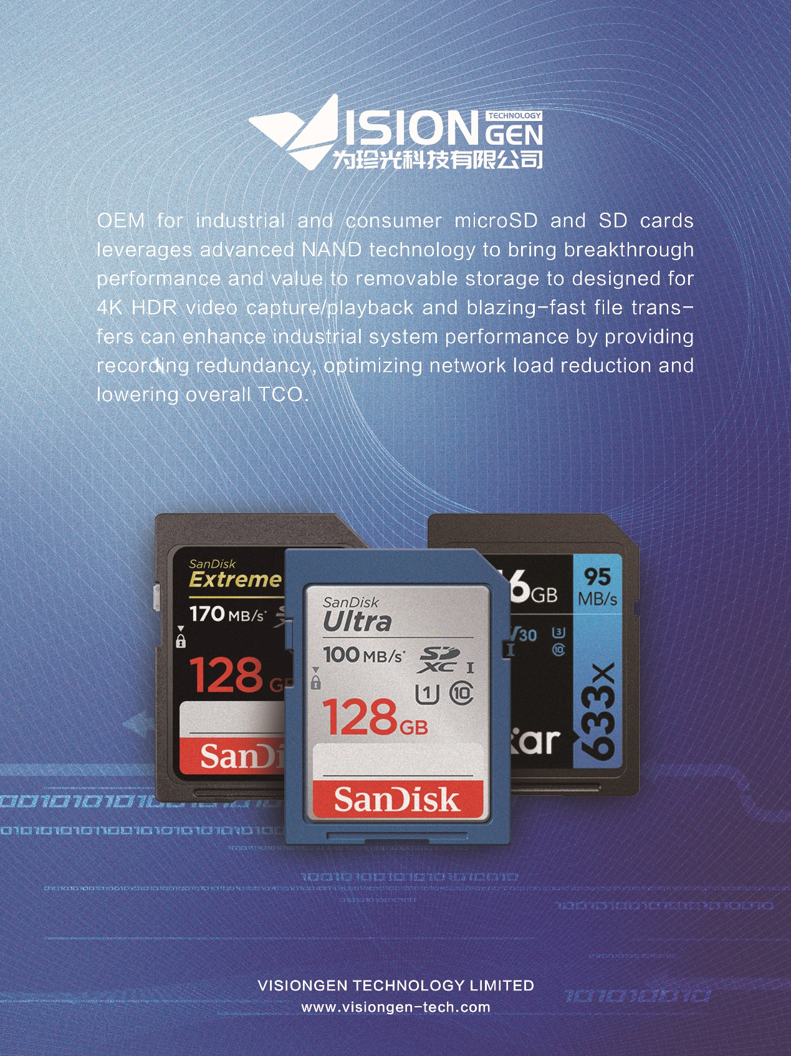

In an increasing data-intensive era we anticipate next-generation mobile and industrial applications to require greater storage for content. We can OEM for industrial and consumer SD cards leverages our advanced NAND technology to bring breakthrough performance and value to removable storage. Selecting a SD specifically designed for 4K HDR video capture/playback and blazing-fast file transfers can enhance industrial system performance by providing recording redundancy, optimizing network load reduction and lowering overall TCO.

128GB to 1TB capacities which store up to 60 hours of 4K HDR video, thousands of 40MP+ photos and mobile apps. Selecting a SD card specifically designed for IP video surveillance cameras can bring more value and enhance system performance by providing recording redundancy and optimizing network load reduction. In addition, it's enabling deployment of NVR-less architectures with lower TCO benefits. Performance Class 30 specification for storing and running applications on removable cards, enabling the applications and games installed on the card to load faster, reads up to 100MB/s, writes up to 95MB/s, write acceleration via cache, intelligent maintenance during idle time for sustained peak performance.

Save time transferring content or capturing more of your favorite moments with a SD card that delivers blazing speeds of up to 100 MB/s reads and 95 MB/s writes. Especially, ready for 4K HDR capture/playback with UHS-1 Speed Class 3 and Video Speed Class 30 support. The recording of video and storing it in the camera instead of in a centralized recording facility across the network - is quickly gaining acceptance and is being more broadly adopted into IP video surveillance applications. Optimized firmware provides stable performance for 24x7 high-quality outstanding video recording performance with minimal frame drops. Meets Application Performance Class 2 (A2), enables built-in memory expansion with compatible Android mobile devices.

Reliable, high industrial quality with 2 million hours mean time to failure (MTTF) or an annualized failure rate of 0.44%, 2X the reliability of surveillance HDDs used in NVRs today. More important, health monitoring feature for IP camera integration reports card usage and lifetime remaining and can be integrated into system software to alert end users.