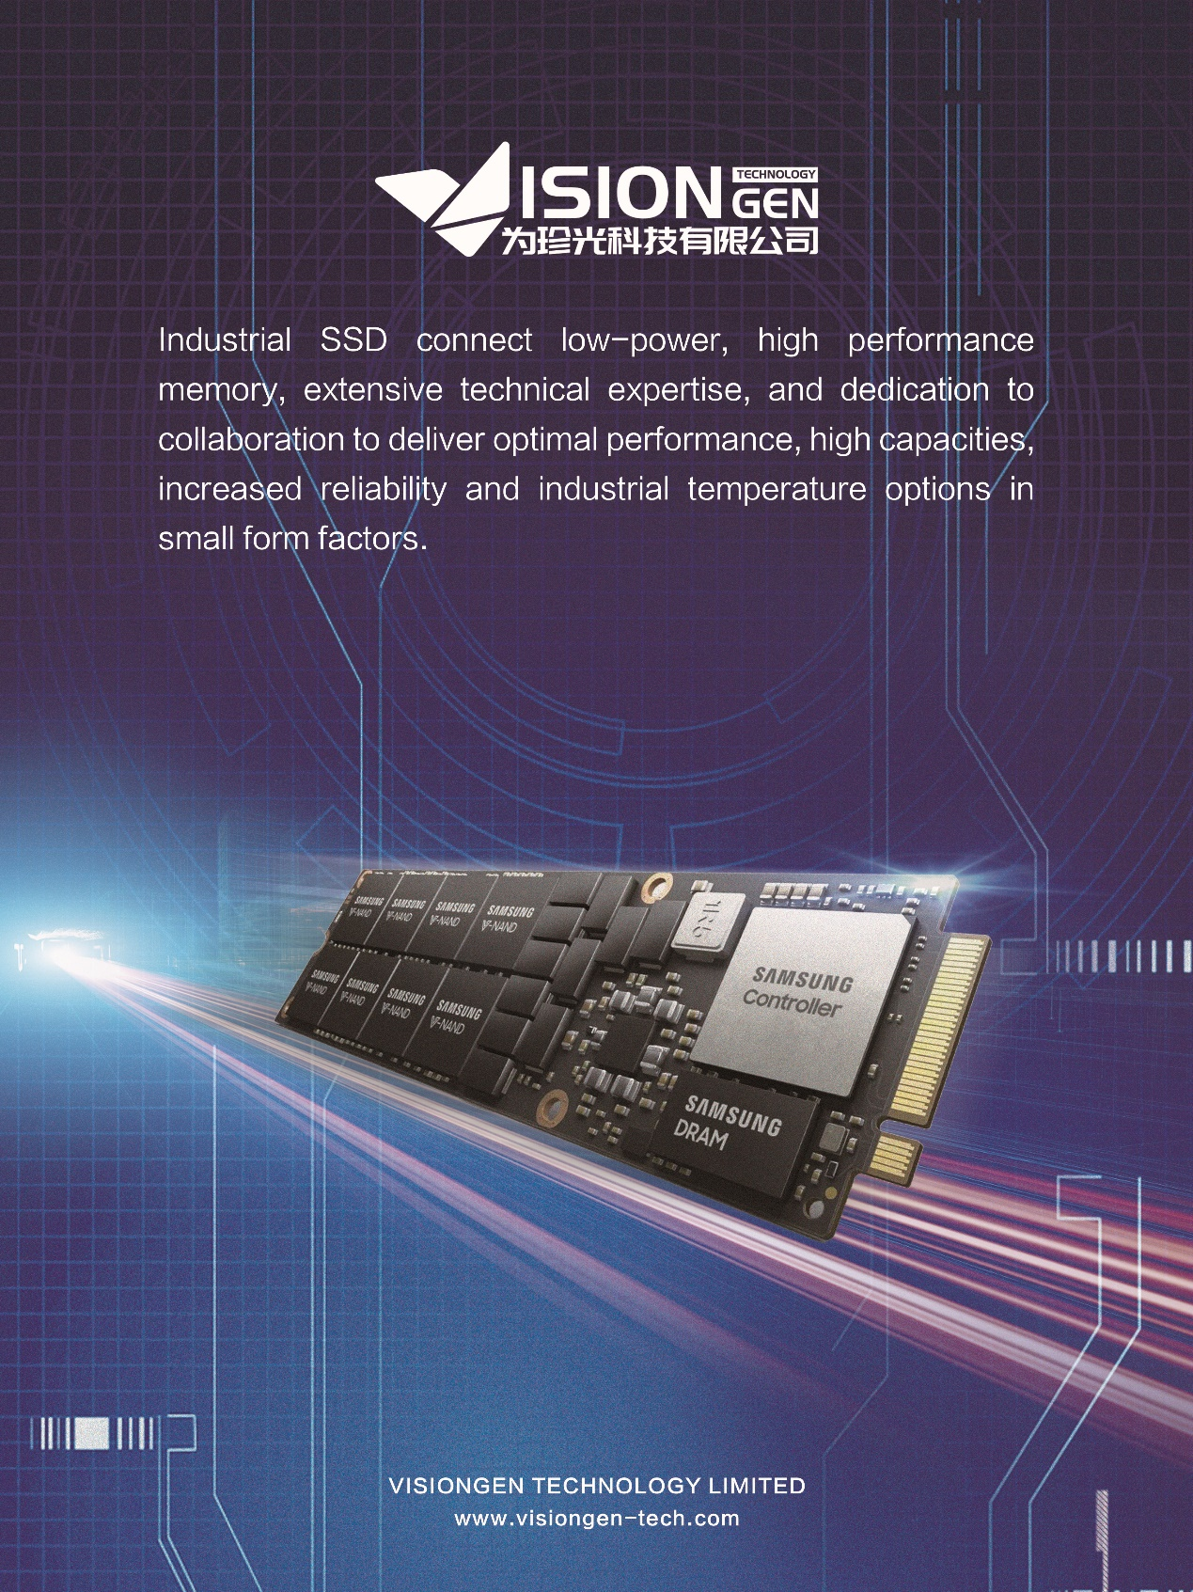

SSD devices connect our lives, looking for by leveraging our low-power, high performance memory, extensive technical expertise, and dedication to collaboration for your next design. Industrial SSD deliver optimal performance, high capacities, increased reliability and industrial temperature options in small form factors.