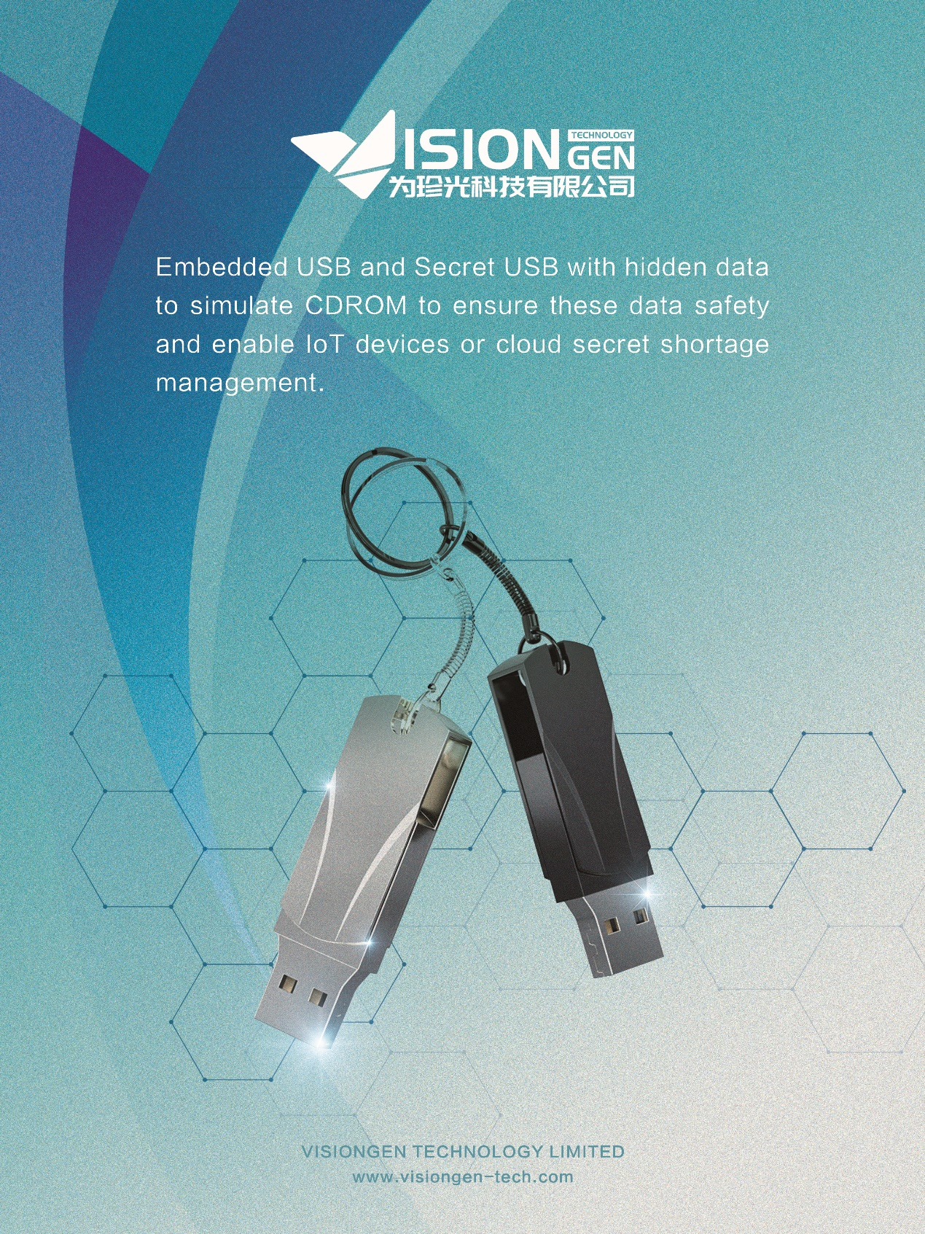

Embedded USB and Secret USB with hidden data to simulate CDROM to ensure our data safety. Our USB solutions enable IoT devices or cloud secret shortage management with collecting, processing and sharing the data that unlocks and expands business insights and outcomes. Designed to offer fast sequential and random access for rapid boot-up and data logging and draws less than 330mW of power when actively reading or writing data.

Fast, reliable, and small - embedded universal serial bus (eUSB) devices offer a compelling alternative to other storage solutions. Designed to offer fast sequential and random access for rapid boot-up and data logging. Our eUSBs provide up to 128GB of USB3.1-compliant memory storage in a small form factor. Includes enhanced features that deliver greater reliability for applications that need it. High performance, reliability and ease of implementation make them an idea storage solution for boot drives and data logging applications such as networking, embedded computing and server systems.

Not only provides a viable option for space-constrained application, but also draws less than 330mW of power when actively reading or writing data. Up to 30X faster than USB2.0 for random operations and auto device initialization for ultra-fast power-up. Of course, eUSB can be backward compatible with previous all kinds of USB generations.

There're four reliability features as following, S.M.A.R.T health reporting, enhanced power-failure protection, dynamic data read disturb management, and enhanced firmware redundancy and recovery.